Bacterial Artificial Chromosomes (BAC)
- Bacterial artificial chromosomes (BACs) are designed for the cloning of large DNA insert (typically 100 to 300 kb) in E. coli host. BAC vectors contain a single copy F-plasmid origin of replication (ori).
- The F (fertility) plasmid is relatively large and vectors derived from it have a higher capacity than normal plasmid vectors. F-plasmid has F (fertility) factor which controls the replication and maintain low copy number. Also, conjugation can take place between F+ bacteria (male) and F- bacteria (female) to transfer F-plasmid via pilus.

- Common gene components of a bacterial artificial chromosome are:
1) oriS, repE – F for plasmid replication and regulation of copy number.
2) parA and parB for maintaining low copy number and avoiding two F plasmids in a single cell during cell division.
3) A selectable marker for antibiotic resistance; some BACs also have lacZ at the cloning site for blue/white selection.
4) T7 and Sp6 phage promoters for transcription of inserted genes.
- The par genes, derived from F plasmid assist in the even distribution of plasmids to daughter cells during cell division and increase the likelihood of each daughter cell carrying one copy of the plasmid, even when few copies are present. The low number of copies is useful in cloning large fragments of DNA because it limits the opportunities for unwanted recombination reactions that can unpredictably alter large cloned DNA over time.
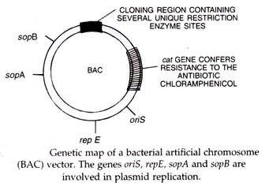
- The first BAC vector, pBAC108L, did not contain a selectable marker for recombinants. Thus, positive recombinants had to be identified by colony hybridization. Two widely used BAC vectors, pBeloBAC11 and pECBAC1, are derivatives of pBAC108L in which the original cloning site is replaced with a lac Z gene carrying a multiple cloning site. PBeloBAC11 has two Eco RI sites, one in the lac Z gene and one in the CMR gene, whereas pECBAC1 has only one Eco RI site in the lac Z gene. Further improvements to BACs have been made by replacing the lac Z gene with the sac B gene which is a negative selection marker. The product of sacB gene is levansucrase which can convert sucrose present in the media into levan, a toxin for the bacteria. Hence the colonies without insert would have intact sacB gene and thus cells die before forming colonies.
- The F plasmid is relatively large and vectors constructed on it have a higher capacity for accepting inserted DNA. A similar cloning vector called a P1-derived artificial chromosome or PAC has also been produced from the bacterial P1 bacteriophage DNA. Both BACs and PACs can be used to clone fragments of 300kb and longer. They are often used to sequence the genome of organisms in genome projects.
Fig: Vector map of pBeloBAC11

